Art in the City

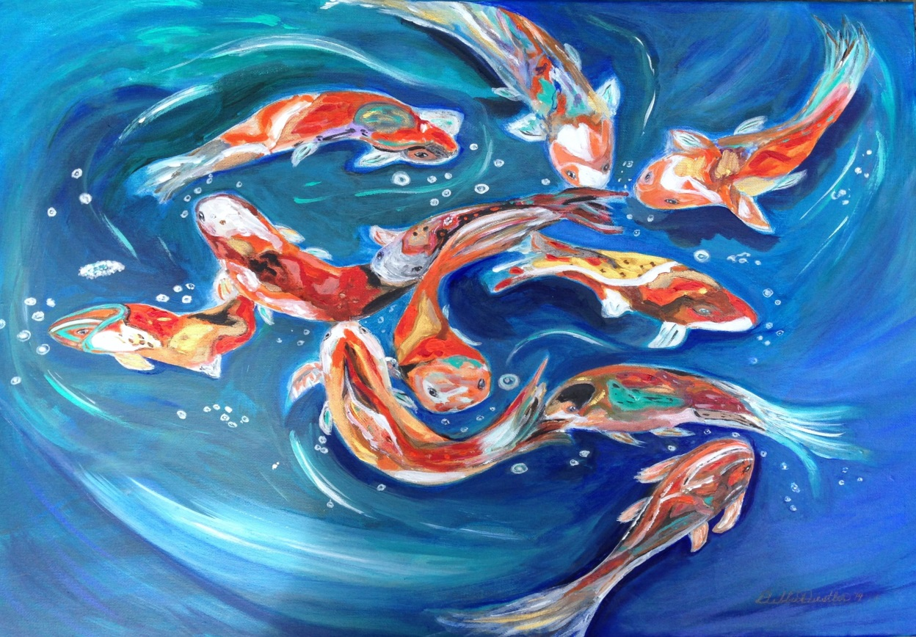
“Koiful”

Event: Art Reception/Cultural Cruise
Hors d’oeuvres and live music

When: Friday, January 27, 2017, 4pm-9pm

Where: City Hall, 777 Cypress Ave., Redding, CA
The first floor lobby of the City Hall,

You are invited to come and see
Debbie Diestler’s art work, along with other local artists.

The show will be up from January 11 – May 1, 2017.

