A HEARTSPECTRUM/ Colorful Creations Event
Collage Classes ~ Taught by Debbie Diestler

Learn about the art of collage and create your own personal art piece in this fun class!
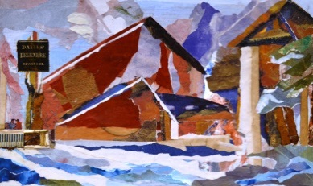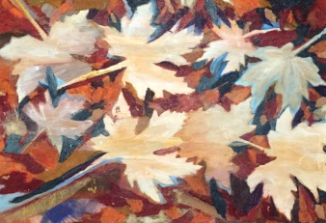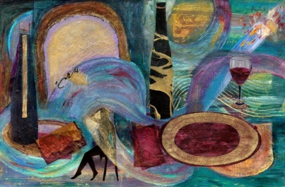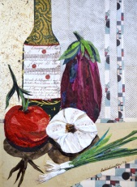
Mountain Retreat Golden Days C’est La Vie Buon Appetito

A collage is artwork that is made from an assemblage of different forms, thus creating a new whole. It may sometimes include newspaper clippings, ribbons, bits of colored or handmade papers, portions of other artwork or texts, letters, fabric, photographs and other found objects, glued to a piece of paper or canvas.

Event: In this four hour class, I will help you create your own unique collage, using acrylic paint and/or paper. Although I will provide all the supplies, I encourage you to be thinking about bits of things you may have saved around your house that you might want to bring and add to your creation. You may have ticket stubs, concert programs, business cards, parts of cards or invitations, special photographs, pictures from a magazine, buttons, handmade papers, stamps, or personal sayings you wish to add to your unique collage.

Date/Time: Friday, March 24, 2017 and/or Saturday, March 25th. 11:00 – 3:00 P.M. both days
Location: NVAL (North Valley Art League) - 48 Quartz Hill Rd., Redding (located in Caldwell Park near the Aquatic Center)
Cost: $40.00 for one day and $70 for both days. Please make checks out to NVAL. All necessary supplies are included.
*** Feel free to bring a sack lunch or your own favorite snacks and a drink.
If you would like to participate, please email me at debd1@frontiernet.net or call/text at (530) 604-0432 and I will put you on my list. Each class is limited to 10 people (open to all art abilities). All adults and children 12 yrs. and older are welcome! The classes will be filled on a first come first served basis.
You may download the flyer and registration attached or get the forms from my website at www.heartspectrum.com Go to Art Connection to check out my Gallery, Shop Cards, Teaching and Up Coming Events.

Please mail the bottom portion of the registration form with your payment (check made out to NVAL) for $40 for one day or $70 for both days to: Debbie Diestler, 31051 Woodridge Dr., Shingletown, CA 96088 by Wednesday, March 22, 2017 or earlier.

I look forward to creating with you in March!

Debbie Diestler
HEARTSPECTRUM
Connecting Through the Arts

