Colorful Creations Event ~ by HEARTSPECTRUM
Taught by Debbie Diestler
Featured Artist – Wolf Kahn
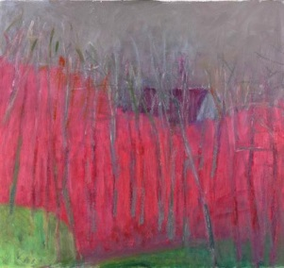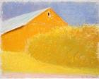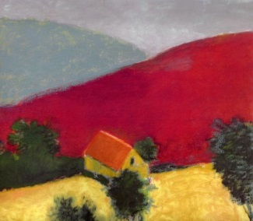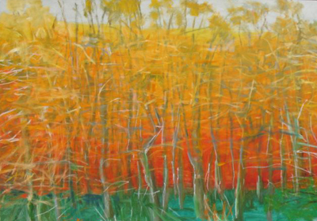
Half Hidden Orange Barn Red Hill Maple Trees in Fall

Event: Come learn about the life and painting style of the landscape colorist, Wolf Kahn. He is a famous German painter who has used representational art in an abstract expressionistic way. We will be using acrylic paint and oil pastels on a 16" x 20" canvas. I will be providing all the supplies you need.

Date/Time: This is different day and time.
Friday, August 18, 2017 ~ 10:00 A.M. to 2:00 P.M.
Location: 31051 Woodridge Dr., Shingletown, CA 96088
Cost: $40.00 All necessary art supplies will be included in this fee.

Light refreshments and beverages will be available, but feel free to bring your own favorite snacks.

You may log onto my website to become familiar with my work at www.heartspectrum.com Go to Art Connection to check out my Gallery, Cards, Teaching and Up Coming Events.

If you would like to participate, please email me at debd1@frontiernet.net or call me at (530) 604-0432. You can download the registration form attached or go onto my website. Mail the bottom portion of the registration with your payment of $40 to Debbie Diestler, to the address on this form, under Location above, by Tuesday, August 15, 2017 or earlier.

I hope to see you in August, at my home in the mountains!
Debbie

Debbie Diestler
HEARTSPECTRUM
Connecting Through the Arts
debd1@frontiernet.net
www.heartspectrum.com
(530) 604-0432

