Colorful Creations Event ~ by HEARTSPECTRUM
Taught by Debbie Diestler
Come be Inspired by Gustav Klimt,
as You Play with Elements of Color, Collage, Pattern and Design

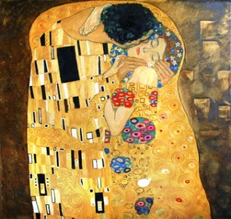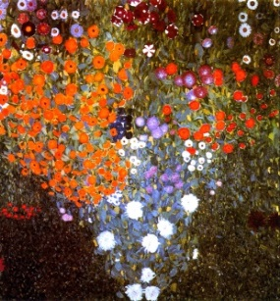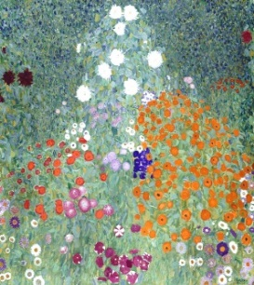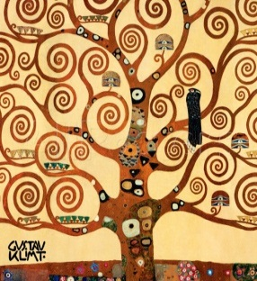

Event: The Austrian artist, Gustav Klimt, was best known for his highly decorative paintings like, “The Kiss”. He was also a wonderful landscape artist. Influenced by Klimt, you will be painting with acrylic paint and embellishing with collage papers on a 16” X 20” canvas or a 12” X 16” mixed media artboard. All supplies will be provided.

Date/Time: Tuesday, January 16, 2018 - 10:00 to 2:30 p.m.
Location: 31051 Woodridge Dr., Shingletown, CA 96088
Cost: $40.00 All necessary art supplies will be included in this fee.

Light refreshments and beverages will be provided, but feel free to bring your own favorite snacks or lunch.

You may log onto my website to become familiar with my work at www.heartspectrum.com Go to Art Connection to check out my Gallery, Cards, Teaching and Up Coming Events.

If you would like to participate, please email me at debd1@frontiernet.net or call me at (530) 604-0432 to be put on my list. You may download the registration form attached or go onto my website. Mail the bottom portion of the registration with your payment of $40 to the address on this form, under Location above, by Friday, January 12, 2018.

I hope you’ll start off the new year creating, during your visit to my home in the mountains!
Debbie

Debbie Diestler
HEARTSPECTRUM
Connecting Through the Arts
debd1@frontiernet.net
www.heartspectrum.com
(530) 604-0432

