HEARTSPECTRUM
Customize Your Colorful Creations Art Event
with Debbie Diestler
www.heartspectrum.com
If you are interested in creating your own party with a group of your favorite friends or family, please consider a fun creative painting event at my home. You may want to paint in the style of a favorite artist, choose your own theme or allow me to help you with ideas and customize your personalized gathering to your liking. All necessary art supplies will be included. Contact Debbie @: debd1@frontiernet.net or call/text (530) 604-0432
If you are interested in a 3 ½ hour private, semi-private or group art lesson please see the following price list:
Cost per Student 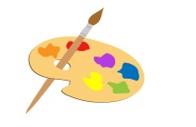Number of Students
$100 1
$ 80 2
$ 60 3
$ 45 4 or more
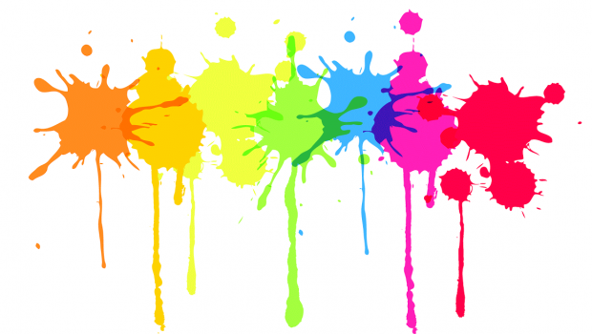
A portion of the proceeds will be donated to The Good News Rescue Mission.

