Colorful Creations Event ~ by HEARTSPECTRUM
Taught by Debbie Diestler
Featured Artist –Marc Chagall

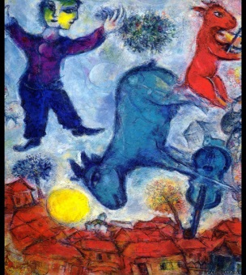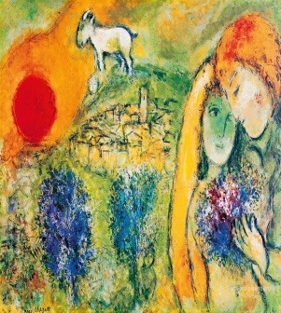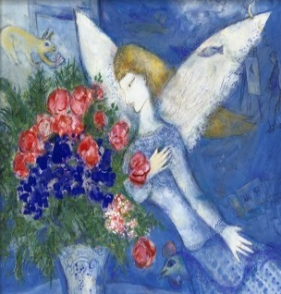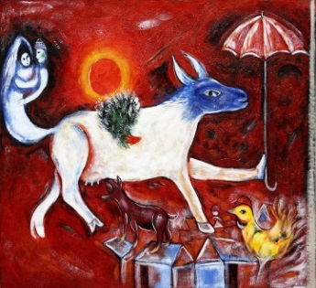

Event: Come play and learn about the life and painting style of Marc Chagall. He painted in several major artistic styles, synthesizing elements of cubism, symbolism and fauvism. He was an important 20th century artist who was also an imaginative and fantasy storyteller. Please be thinking about a story you might like to create on canvas, from your own life experience or your imagination.

Date/Time: Saturday, April 14, 2018
10:00 A.M. to 1:30 P.M.
Location: 31051 Woodridge Dr., Shingletown, CA 96088
Cost: $40.00 All necessary art supplies will be included in this fee. (Just wear your play clothes or bring a cover up to protect your clothes.)
Please let me know if you are coming, no later than Wednesday, April 11, 2018.

Light refreshments and beverages will be available, but feel free to bring your own favorite snacks.

You may log onto my website to become familiar with my work at www.heartspectrum.com Go to Art Connection to check out my Gallery, Cards, Teaching and Up Coming Events.

I will need a minimum of 4 students to teach this class. If you would like to participate, please email me at debd1@frontiernet.net or call me at (530) 604-0432. You can download the registration form attached or go onto my website. Mail the bottom portion of the registration with your payment of $40 to the address on this form, under Location above, by Wednesday, April 11, 2018.

I hope to see you soon!
Debbie

Debbie Diestler
HEARTSPECTRUM
www.heartspectrum.com
debd1@frontiernet.net
(530) 604-0432

Connecting Through the Arts

